Honeywell Xenon Barcode Scanner Programming Chart

The following barcodes program the Xenon scanner’s Post Fix characters

Note after scanning the Programming code return the scanner to the base unit and wait for the Scanner to reconnect with the base after programming you will hear tones and flashing lights,

This reconnection is normally done within 20 Seconds

After programming the device will return the content of the Barcode nothing will be added or removed other than the Postfix indicated.

Data With <CR LF> (Enter) at End

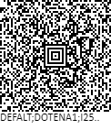

Data With <TAB> at End

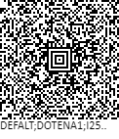

Data Only (No postfix) at End

